Hexeno

Isómeros do hexeno desenhados:

• 1-Hexeno

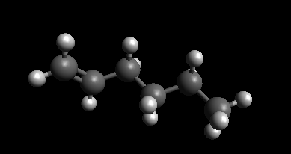

• (E)-2-Hexeno

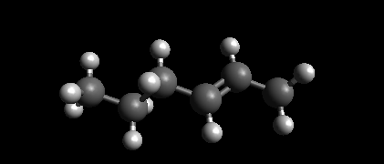

• (Z)-2-Hexeno

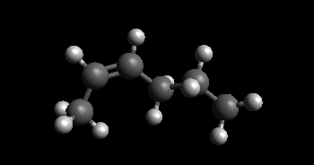

• (E)-3-Hexeno

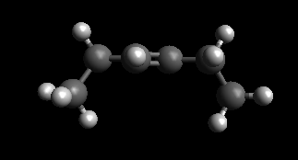

• (Z)-2-Hexeno

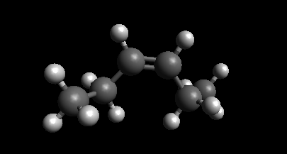

Ciclo-Hexano

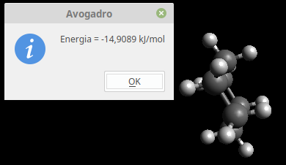

Comparar das energias :

|  |  |
| --- | --- |
| Molécula | Energia (KJ/mol) |
| 1-Hexeno | 21,1004 |
| (E)-2-Hexeno | 14,9294 |
| (Z)-2-Hexeno | 22,0311 |
| (E)-3-Hexeno | 11,1267 |
| (Z)-3-Hexeno | 16,7911 |
| Ciclo-hexano | -14,909 |

B)

Butano:

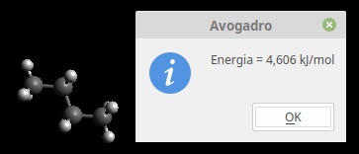

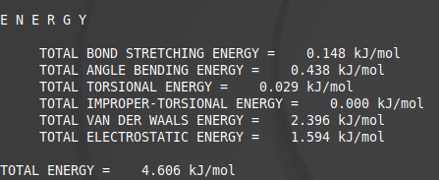

Hexafluorobutano:



